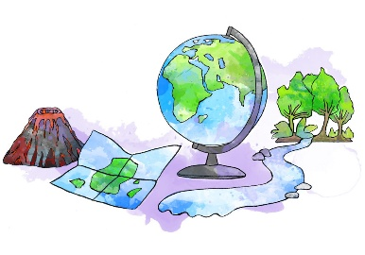
A Level Geography: Transition Work – Year 11
In Year 12, we study Coast and Changing Places
Your summer tasks are designed to introduce key geographical knowledge, develop your research skills, and get you thinking critically about geography.
Task 1: Engage with Geography in the media
How do I do this? Watch or read geography-related content once a week. Below are some ideas of media that you can watch. You can choose from:
Films:  A Plastic Ocean  BBC One - Climate Change - The Facts | YouTube Documentaries :  Explained | World's Water Crisis | FULL EPISODE | Netflix  Theories of development | RGS | Podcast:  BBC World Service - 50 Things That Made the Modern Economy, Shipping Container  A conversation with Tim Marshall | RGS
What do I need to do? Write a short reflection (about half a page) on what you watched or read, what you learned from it and how it might link to the topics we’ll study. Aim to complete 2 media reflections over the summer. Include:
Task 2: Geographical Research – Case Studies Odisha and Detroit
Get used to researching and forming case studies information – a key A level skill.
What to do: Research and create one-page case studies for:
- Odisha - cyclone risk, coastal flooding, mangrove forests AND Integrated Coastal Zone Management (ICZM)
- Detroit – rise and fall, car manufacturing, white flight, dereliction and regeneration
Task 3: Explore a Geographical Issue that Interests You
Choose one geographical issue related to either human and physical geography. Some of the topics at A level are Paper 1 Carbon and Water, Coasts and Hazards Paper 2 Global Systems and Governance and Contemporary Urban Environments.
Write a one-page reflection that includes:
- A summary of the issue – key facts and where you found them
- Why it interests you – does it connect to your own experiences or beliefs?
- How the issue impacted society
Your To Do List:
[ ] 2 Geography media reflections (films, documentaries, etc.) [ ] 2 case studies
[ ] 1 page reflection on a geographical issue you're passionate about

