
BTEC Applied Science
Unit 1 Transition Project
Year 11 into Year 12: Chemistry, Biology and Physics
Principles and Applications of Science I
Student name
Form group
Deadline
Teacher
Project purpose
This project bridges GCSE Science and Level 3 BTEC Applied Science. It focuses on key Unit 1 knowledge: chemistry atomic structure and bonding, biology cells and biological molecules, and physics waves and communication. You should aim to explain, compare and apply ideas, not just list facts.

How to present your work
- Produce a neat booklet, typed document or digital portfolio of 8-12 pages.
- Use clear headings, labelled diagrams, keywords and completed tables.
- Write in your own words and include a short reference list.
- Use GCSE knowledge as your starting point, then add Level 3 detail.

Academic challenge
Level | What your work should show
Pass | Accurate descriptions of core biology, chemistry and physics knowledge.
Merit | Clear explanations that link structure to function, bonding to properties, and wave behaviour to applications.
Distinction | Detailed comparisons, accurate terminology, extended reasoning and application to real scientific contexts.

C | SECTION A: CHEMISTRY - Atomic Structure and Bonding

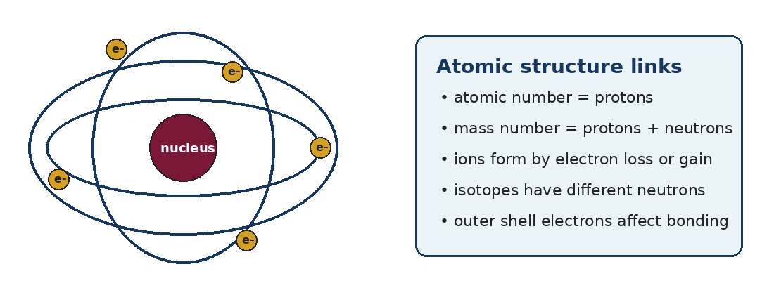

Task C1: Atomic structure knowledge organiser
- Draw and label an atom, showing nucleus and electron shells.
- Define proton, neutron, electron, atomic number, mass number, ion and isotope.
- Explain how to calculate protons, neutrons and electrons from atomic and mass numbers.
- Compare atoms, ions and isotopes in a small table.
Stretch thinking
Explain why isotopes of the same element have the same chemical properties but different masses.

Task C2: Electronic structure
Element | Atomic number | Electron arrangement | Outer-shell electrons
Lithium | 3
Carbon | 6
Oxygen | 8
Sodium | 11
Magnesium | 12
Chlorine | 17
Calcium | 20
- How does the number of outer-shell electrons link to group number?
- Why do atoms react to gain, lose or share electrons?
- Why are noble gases usually unreactive?

Task C3: Bonding and properties
Bonding type | What happens to electrons? | Structure formed | Example | Key properties
Ionic |  |  | sodium chloride
Simple covalent |  |  | water / carbon dioxide
Giant covalent |  |  | diamond / graphite
Metallic |  |  | copper / aluminium
Challenge paragraph
Explain how bonding and structure affect melting point, boiling point, hardness, solubility and electrical conductivity. Use named examples from the table.

C+ | CHEMISTRY EXTENSION - Structure, Properties and Materials

Task C4: Compare two materials in depth
- Choose two materials: sodium chloride, graphite, diamond, copper, aluminium, silicon dioxide or a polymer.
- For each material, describe its bonding, structure and at least four physical properties.
- Explain why each property occurs using particles, forces and electron behaviour.
- Compare the two materials directly: What is similar? What is different? Why?
Level 3 writing frame
The particles in ___ are arranged as ___. The forces between particles are ___. This explains why ___ has a ___ melting point because ___. It can/cannot conduct electricity because ___.

Task C5: Short calculation and application questions
- Magnesium has atomic number 12 and mass number 24. State the number of protons, neutrons and electrons in a neutral magnesium atom.
- Chlorine has isotopes chlorine-35 and chlorine-37. Explain what is different about these atoms.
- Explain why magnesium oxide has a higher melting point than many simple covalent molecules.
- Explain why copper is used for electrical wiring but diamond is used for cutting tools.

B | SECTION B: BIOLOGY - Cells, Specialisation and Biological Molecules

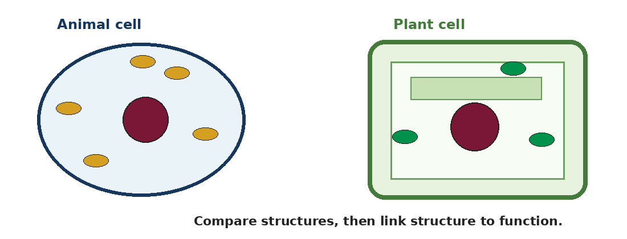

Task B1: Cell structure
- Draw and label one animal cell and one plant cell.
- Complete a function table for: nucleus, cytoplasm, cell membrane, mitochondria, ribosomes, cell wall, chloroplasts and vacuole.
- Explain which structures are shared by plant and animal cells and which are plant-only.

Task B2: Specialised cells
- Choose three specialised cells: red blood cell, sperm cell, egg cell, nerve cell, muscle cell, root hair cell, ciliated epithelial cell or white blood cell.
- For each cell, include a labelled diagram, its function and at least three adaptations.
- Explain how each adaptation helps the cell carry out its role.
Stretch thinking
Why do multicellular organisms need specialised cells rather than all cells being the same?

Task B3: Biological molecules
Biological molecule | Made from | Function in the body | Food/cell example
Carbohydrates
Lipids
Proteins
Nucleic acids
- Why are proteins important for growth and repair?
- Why are enzymes described as biological catalysts?
- Why is DNA important in cells?
- How does DNA store genetic information?

P | SECTION C: PHYSICS - Waves and Communication

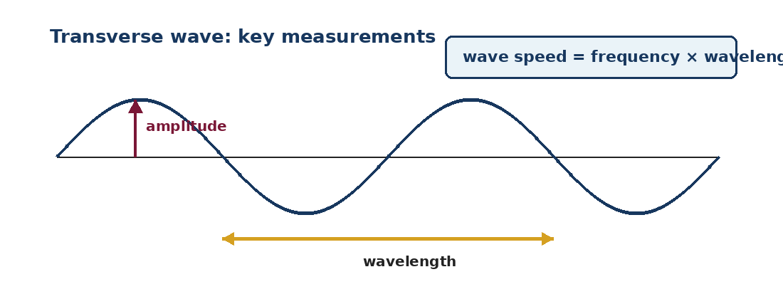

Task P1: Wave knowledge organiser
- Draw and label a transverse wave and a longitudinal wave.
- Define amplitude, wavelength, frequency, wave speed, crest, trough, compression and rarefaction.
- Explain the difference between transverse and longitudinal waves using examples.
Key equation
wave speed = frequency x wavelength. Include units and show full working in calculations.

Task P2: Wave calculations
- A wave has a frequency of 5 Hz and a wavelength of 2 m. Calculate the wave speed.
- A sound wave travels at 340 m/s and has a frequency of 170 Hz. Calculate the wavelength.
- A radio wave has a speed of 300,000,000 m/s and a wavelength of 2 m. Calculate the frequency.
- Explain why it is important to rearrange equations carefully and include units.

Task P3: Electromagnetic spectrum
- Create a labelled diagram of the electromagnetic spectrum in the correct order.
- For radio waves, microwaves, infrared, visible light, ultraviolet, X-rays and gamma rays, include one use and one possible danger where appropriate.
- Explain which waves have the longest wavelength and which have the highest frequency.
Stretch thinking
Explain how electromagnetic waves are used in hospitals, including benefits and risks.

S | SCIENTIFIC SKILLS AND FINAL APPLICATION TASK

Task S1: Practical skills
- Choose one practical from chemistry, biology or physics.
- Write the aim, equipment, method, variables, safety precautions and expected results.
- Identify possible errors and explain how accuracy, precision, reliability and validity could be improved.
Term | Definition | Example from a practical
Accuracy
Precision
Reliability
Validity

Task S2: Applied science in the real world
- Choose one real-world application of science and write one detailed page.
- Explain the key science behind it, how it is used, why it is useful and any risks or limitations.
- Include one labelled diagram, one data fact if available, and a short reference list.
Suggested topics
Bonding in medical materials; graphite or silicon in technology; specialised cells in the human body; electromagnetic waves in hospitals; enzymes in industry; waves in communication systems.

Project submission checklist
Requirement | Tick
Clear title page
Chemistry tasks completed
Biology tasks completed
Physics tasks completed
At least three labelled diagrams
All tables completed
Calculations show full working
Keywords used accurately
Final application task completed
Reference list included

R | USEFUL VOCABULARY AND REFERENCE LIST

Chemistry
Atom, proton, neutron, electron, ion, isotope, electronic structure, ionic bond, covalent bond, metallic bond, electrostatic attraction, delocalised electrons, lattice, conductivity.

Biology
Cell, tissue, organ, nucleus, cytoplasm, cell membrane, mitochondria, ribosome, chloroplast, specialised cell, adaptation, carbohydrate, lipid, protein, enzyme, DNA.

Physics
Wave, transverse, longitudinal, amplitude, wavelength, frequency, wave speed, electromagnetic spectrum, radiation, reflection, refraction, accuracy, precision, reliability.

Reference list
List the websites, textbooks or revision guides you used. Write the name of the source and the date you accessed it. Do not copy and paste large sections of text; summarise ideas in your own words.
1. _________________________________________________________________________________________________________
2. _________________________________________________________________________________________________________
3. _________________________________________________________________________________________________________
4. _________________________________________________________________________________________________________
5. _________________________________________________________________________________________________________
6. _________________________________________________________________________________________________________

Appendix: BTEC Unit 8 LA A - Distinction Planning Checklist
Use this to plan high-quality, independent work. It gives guidance only and does not reproduce the official assignment brief.
Focus: musculoskeletal system, movement, disorders and corrective treatments. To aim high, move beyond description: compare, explain and evaluate using accurate scientific language.
1 | Explain the musculoskeletal system  - Introduce the structure and role of bones, muscles, joints, tendons, ligaments, cartilage and synovial fluid.  - Explain support, movement, protection of organs, blood cell production and mineral storage.  - Add clear labelled diagrams where useful.

2 | Explain how movement happens  - Explain how bones, muscles and joints work together, including bones as levers and antagonistic pairs.  - Use key terms accurately: flexion, extension, abduction, adduction, rotation and circumduction.  - Include tendons, ligaments and how muscles contract and relax.

3 | Describe six major joints  - Create a table for shoulder, elbow, wrist, hip, knee and ankle, or six other appropriate major joints.  - For each joint include bones, muscles, ligaments/tendons and type of movement.  - Add a sentence explaining how the structure of each joint helps movement.

4 | Research three musculoskeletal disorders  - Choose three disorders affecting different parts of the musculoskeletal system.  - Examples: rheumatoid arthritis, osteoarthritis, ACL injury, shoulder dislocation, osteoporosis or joint hypermobility.  - For each disorder describe the body part affected, symptoms, effect on movement, impact on daily life/work and treatments.

5 | Compare the three disorders  - Create a comparison table covering cause, area affected, movement, pain/mobility, short-term impact, long-term impact and treatments.  - Clearly explain similarities and differences rather than describing each condition separately.

6 | Explain corrective treatments  - For each disorder, explain treatments such as physiotherapy, exercise, rest, pain relief, NSAIDs, steroid injections, surgery, braces, lifestyle changes or complementary therapies.  - For each treatment, explain how it works and why it may help.

7 | Evaluate one disorder in detail  - Choose one disorder to evaluate fully and compare different treatments.  - Include strengths, weaknesses, short-term and long-term benefits, side effects, risks, limitations, impact on movement, quality of life and return to work/activity.  - Finish by deciding which treatment or combination is most effective and explain why.

8 | Use scientific language and references  - Use accurate terminology: synovial joint, cartilage, ligament, tendon, inflammation, range of movement, antagonistic muscles, corrective treatment and rehabilitation.  - Use reliable sources such as NHS, textbooks, class notes, anatomy websites and physiotherapy resources.  - Write in your own words and include a reference list.

Suggested six-joint table
Joint | Bones involved | Muscles involved | Ligaments/tendons | Movement
Shoulder / elbow / wrist / hip / knee / ankle | Name the bones | Name key muscles | Name key structures | State movements possible

Final work should include
☐ Introduction to the musculoskeletal system | ☐ Explanation of movement | ☐ Six major joints table
☐ Three disorders described | ☐ Comparison of the three disorders | ☐ Treatments explained
☐ Detailed evaluation of one disorder and its treatments | ☐ Diagrams/images | ☐ Reference list
Distinction reminder: You need to evaluate, not just describe. Make clear judgements about which treatments are most effective, using scientific explanations and evidence to support your ideas.

