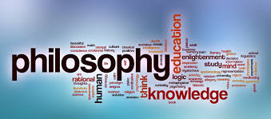**A level Religious Studies: Transition work– Year 11**

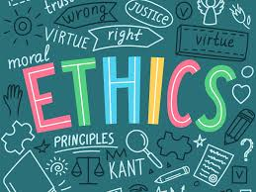

**Task 1: What is Philosophy and Ethics?**

Go to the two links below:

- What is Philosophy (Crash Course) <https://www.youtube.com/watch?v=1A_CAkYt3GY>

Watch each of the videos one at a time. We recommend watching it once fully without making notes and then a second time to be able to write things down that you found.

- What is Ethics?

<https://www.youtube.com/watch?v=u399XmkjeXo>

- Now, summarise the main ideas of each video.

**Task 2: Key scholar research**

In Philosophy and Ethics you will be introduced to many scholars to support arguments you make in your essays. Create a summary sheet/flyer about 3 of the scholars below.

In this you need to make sure you have completed the following success criteria:

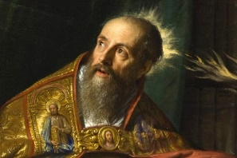- When were they alive?

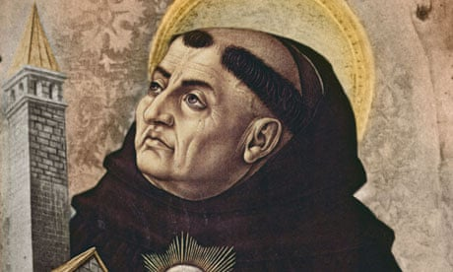- What key books did they write?

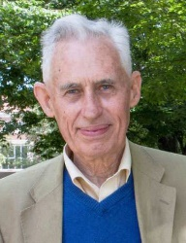- What key issues did they write about?

- Are there any key quotes?

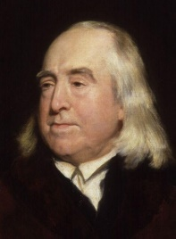The following scholars to choose to research from are:

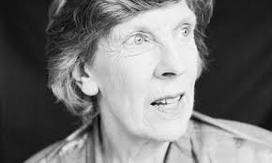- St Augustine

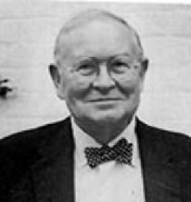- St Thomas Aquinas

- Richard Swinburne

- Joseph Fletcher

- Jeremy Bentham

- Philippa Foot

**Your to do list:**

1. Watch the two clips about Philosophy and Ethics and summarise what each says.
2. Choose 3 scholars from the list in task 2 and create a summary sheet answering the key questions given in task 2.