**A level Art: Transition work– Year 11**

**Creative Investigation**

**Pick one of the following subthemes to explore and present on A3 paper​ ​**

**LAYERS SYMBOLISM ABSTRACTION**

**Select an artist linking to 1 of the themes ​**

1. **Analyse ONE of their images (use the help sheet overleaf) and produce an artist response​**
2. **Take 20+ photos to help explore your theme.​**
3. **Develop AT LEAST 1 A3 sheet of ideas – you need 3 composition ideas linking to your chosen artist and theme.​**
4. **Produce an A5 or bigger outcome in materials of your choice – make sure this has impact, make the viewer go WOW! ​**

**Present your outcome – this could be framed or presented any way you choose.**

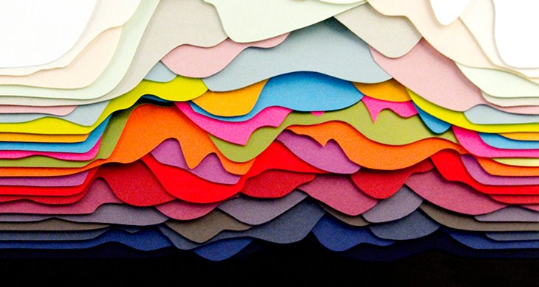 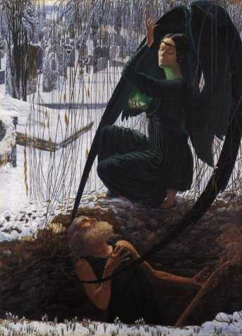 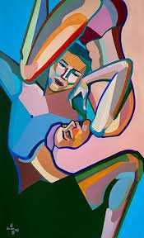 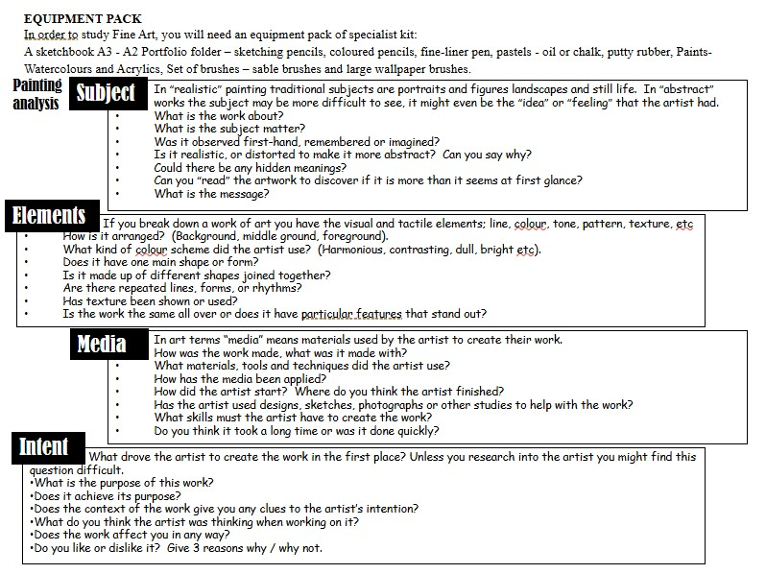

**Actions for your summer:**

Complete Task 1

Complete Task 2

Complete Task 3

Complete Task 4